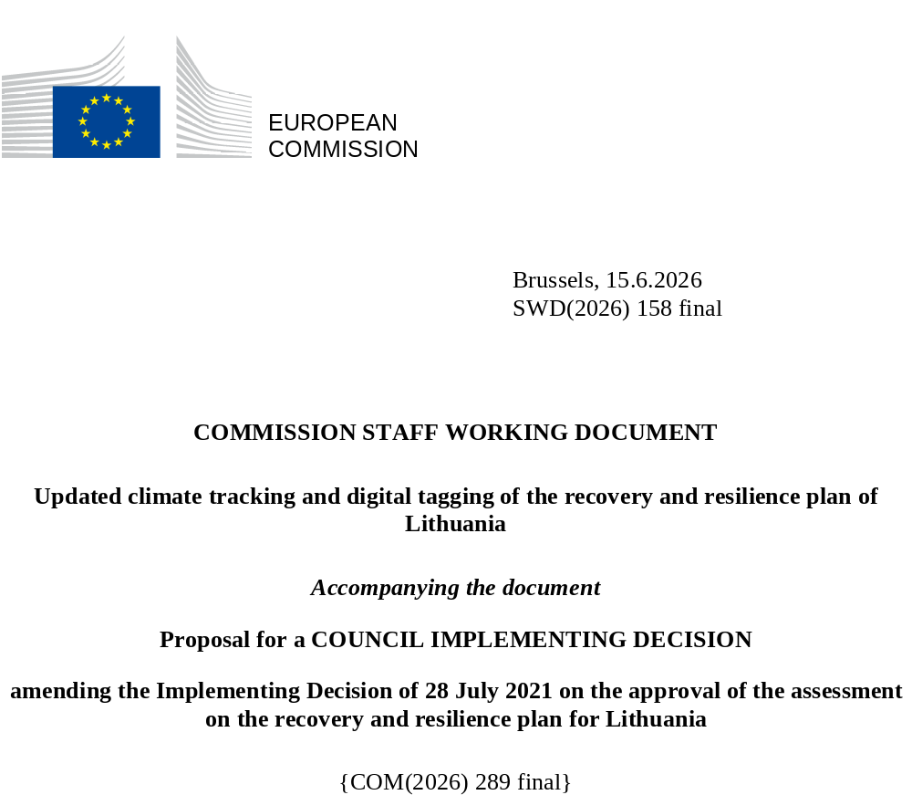

Executive summary
The modifications submitted by Lithuania under Article 21(1) of Regulation (EU) 2021/241 affect 31 (sub-)measures in total. Lithuania requested to modify these 31 (sub-)measures due to objective circumstances.
In addition, the proposed amendments to the Lithuanian recovery and resilience plan aim to adapt the plan in line with the Communication from the Commission to the European Parliament and the Council “NextGenerationEU – the Road to 2026”.
Based on the assessment of the submitted modifications, the Lithuanian modified plan receives an A-rating on all criteria except for costing, where the plan receives a B-rating (unchanged from the original plan assessment).
(1)  Balanced Response | (2)  CSRs | (3)  Growth, jobs… | (4)  DNSH | (5)  Green target | (6)  Digital target | (7)  Lasting impact | (8)  M & T | (9)  Costing | (10)  Control Systems | (11)  Coherence | (12) REPowerEU | (13) Cross-border
A | A | A | A | A  37.2% | A  23.42% | A | A | B | A | A | A | A

Updated climate tracking and digital tagging of the recovery and resilience plan of Lithuania

The table below presents the detailed application of the climate tracking and digital tagging methodologies set out respectively in Annexes VI and VII to Regulation (EU) 2021/241 in the modified Lithuanian recovery and resilience plan.
- Int. Field = intervention field.
- Coeff. = Coefficient for the calculation of support to climate change objectives and to digital transition, on the basis of Annex VI and Annex VII of the RRF Regulation.
- New or revised measures are marked in green to distinguish them from the unchanged measures in the RRP.
- As the amount of the estimated total costs of the amended RRP is equal to the updated maximum financial contribution available for Lithuania, all spending related to the measures mentioned in this table as contributing to climate objectives are fully financed by the funds from the Recovery and Resilience Facility.
- Reforms and investments in the REPowerEU chapter are not taken into account when calculating the plan’s contribution to the digital target requirement set by Regulation (EU) 2021/241.
Measure / Sub-measure ID | Measure / Sub-measure Name | Budget (EUR m) | Climate |  | Digital
Measure / Sub-measure ID | Measure / Sub-measure Name | Budget (EUR m) | Int. Field | Coeff. % | Int. Field | Coeff. %
LT-C[C1]-R[A-1-1-.A-1-1-10-] | Development of healthcare quality assessment model | 2.5 |  | 0% | 4-011 | 100%
LT-C[C1]-R[A-1-1-.A-1-1-11-] | Digitalisation of the healthcare sector | 50.1 |  | 0% | 4-095 | 100%
LT-C[C1]-R[A-1-1-.A-1-1-7-a-] | Creation of Centre for Advanced Therapies - Construction | 13.4 |  | 0% |  | 0%
LT-C[C1]-R[A-1-1-.A-1-1-7-b-] | Creation of Centre for Advanced Therapies - Equipment | 5.1 |  | 0% |  | 0%
LT-C[C1]-R[A-1-1-.A-1-1-8-] | Creation a representative collection of reference genome data within the health project “Genome Europe” | 6.3 |  | 0% |  | 0%
LT-C[C1]-R[A-1-1-.A-1-1-9-] | Establishment of Health Professionals Competence Platform | 1.3 |  | 0% | 4-011 | 100%
LT-C[C1]-R[A-1-2-.A-1-2-2-a-] | Increase of human resources and infrastructure capacity for the provision of long-term care services - Day Centres (installation) | 5.4 | 026 | 40% |  | 0%
LT-C[C1]-R[A-1-2-.A-1-2-2-b-] | Increase of human resources and infrastructure capacity for the provision of long-term care services - Day centres and mobile commands (equipment and vehicles) | 3.5 |  | 0% |  | 0%
LT-C[C1]-R[A-1-2-.A-1-2-2-c-] | Increase of human resources and infrastructure capacity for the provision of long-term care services - Training | 2.1 |  | 0% |  | 0%
LT-C[C1]-R[A-1-3-.A-1-3-2-a-] | Modernisation of Centres of expertise in the cluster of infectious diseases - Construction | 92.2 |  | 0% |  | 0%
LT-C[C1]-R[A-1-3-.A-1-3-2-b-] | Modernisation of Centres of expertise in the cluster of infectious diseases - Equipment | 21.7 |  | 0% |  | 0%
LT-C[C1]-R[A-1-3-.A-1-3-3-a-] | Modernisation of emergency departments and resuscitation units in regional hospitals - Reconstruction | 24.0 | 026 | 40% |  | 0%
LT-C[C1]-R[A-1-3-.A-1-3-3-b-] | Modernisation of emergency departments and resuscitation units in regional hospitals - Equipment | 13.6 |  | 0% |  | 0%
LT-C[C2]-I[B-1-4-.B-1-4-] | Maintaining and increasing GHG absorption capacity | 2.0 | 037 | 100% |  | 0%
LT-C[C2]-I[B-3-1-.B-3-1a-] | Establishment of The Green Finance Competence and Knowledge Center | 2.5 |  | 0% |  | 0%
LT-C[C2]-R[B-1-1-.B-1-1-1-] | Preparatory work for the development of offshore wind power plants and related infrastructure | 7.3 | 028 | 100% |  | 0%
LT-C[C2]-R[B-1-1-.B-1-1-2-b-] | Support for the construction of individual energy storage facilities | 52.6 | 033 | 100% | 4-033 | 40%
LT-C[C2]-R[B-1-1-.B-1-1-3-] | Installation of other electricity storage infrastructure | 100.0 | 033 | 100% | 4-033 | 40%
LT-C[C2]-R[B-1-2-.B-1-2-1-a-] | Support for the purchase of clean vehicles by the public sector and business - Purchase of clean cars | 4.9 | 074 | 100% |  | 0%
LT-C[C2]-R[B-1-2-.B-1-2-1-b-] | Support for the purchase of clean vehicles by the public sector and business - Purchase of less polluting buses | 0.1 |  | 0% |  | 0%
LT-C[C2]-R[B-1-2-.B-1-2-1-c-] | Support for the purchase of clean vehicles by the public sector and business - Support for the production of electric buses (assembly) | 0.4 | 074 | 100% |  | 0%
LT-C[C2]-R[B-1-2-.B-1-2-1-d-] | Support for the purchase of clean vehicles by the public sector and business – Development of bicycle and foot paths infrastructure | 49.0 | 075 | 100% |  | 0%
LT-C[C2]-R[B-1-2-.B-1-2-1-e-] | Support for the purchase of clean vehicles by the public sector and business – Railway electrification | 38.5 | 067 | 100% |  | 0%
LT-C[C2]-R[B-1-2-.B-1-2-2-] | Support for the purchase of zero-emission public transport vehicles | 65.4 | 074 | 100% |  | 0%
LT-C[C2]-R[B-1-2-.B-1-2-3-a-] | Installation of vehicle charging/alternative fuel filling infrastructure - Expansion of refuelling/charging infrastructure | 1.3 | 077 | 100% |  | 0%
LT-C[C2]-R[B-1-2-.B-1-2-3-b-] | Installation of vehicle charging and alternative fuel filling infrastructure - Installation of recharge/charge infrastructure (public transport) | 6.0 | 073 | 100% |  | 0%
LT-C[C2]-R[B-1-2-.B-1-2-3-c-] | Installation of vehicle charging/alternative fuel filling infrastructure - Installation of recharging points for private electric vehicles | 22.9 | 077 | 100% |  | 0%
LT-C[C2]-R[B-1-2-.B-1-2-4-a-] | Support to develop RES fuels sector (biomethane gas, second generation liquid biofuels for transport, and green hydrogen) - Establishment of biomethane gas production capacity | 13.6 | 030bis | 100% |  | 0%
LT-C[C2]-R[B-1-2-.B-1-2-4-b-] | Support to develop RES fuels sector (biomethane gas, second generation liquid biofuels for transport, and green hydrogen) - Installation of second generation biofuel production capacity | 8.7 | 030bis | 100% |  | 0%
LT-C[C2]-R[B-1-2-.B-1-2-4-c-] | Support to develop RES fuels sector (biomethane gas, second generation liquid biofuels for transport, and green hydrogen) - Development of green hydrogen technologies and their use | 20.0 | 032 | 100% |  | 0%
LT-C[C2]-R[B-1-3-.B-1-3-2-] | Tools to facilitate building renovation coordination and technical assistance | 3.0 | 026bis | 100% | 4-011 | 100%
LT-C[C2]-R[B-1-3-.B-1-3-3-] | Promoting the supply of construction products and services that speed up the renovation of buildings | 10.1 | 022 | 100% |  | 0%
LT-C[C2]-R[B-1-3-.B-1-3-4-] | Support for renovation of buildings | 164.6 | 025bis | 100% |  | 0%
LT-C[C3]-I[C-1-4-.C-1-4-1-] | Development of Lithuanian-language technological resources | 35.0 |  | 0% | 3 - 012 | 100%
LT-C[C3]-I[C-1-4-.C-1-4-2-] | Digitisation and accessibility of cultural resources | 30.0 |  | 0% | 5-021bis | 100%
LT-C[C3]-I[C-1-4-.C-1-4-3-] | Production of digital education content and resources | 20.0 |  | 0% | 3 - 012 | 100%
LT-C[C3]-I[C-1-4-.C-1-4-4-a-] | Financial instruments for business creation and digital innovation - Developing and deploying digital innovation | 15.9 |  | 0% | 2 -009bis | 100%
LT-C[C3]-I[C-1-4-.C-1-4-4-b-] | Financial instruments for business creation and digital innovation - Development and deployment of ESA and AI solutions | 1.5 |  | 0% | 6-021ter | 100%
LT-C[C3]-I[C-1-4-.C-1-4-5-] | ICT Centre of excellence | 14.0 |  | 0% | 2 -009bis | 100%
LT-C[C3]-I[C-1-5-.C-1-5-2-] | Further development of very high capacity networks | 49.0 |  | 0% | 1 - 054 | 100%
LT-C[C3]-I[C-1-5-.C-1-5-3-] | Innovation in mobility | 24.5 |  | 0% | 1 - 054 | 100%
LT-C[C3]-R[C-1-1-.C-1-1-a-] | Transformation of public information technology governance - Development of ICT infrastructure | 95.0 |  | 0% | 4 - 011 | 100%
LT-C[C3]-R[C-1-1-.C-1-1-b-] | Transformation of public information technology governance - Ensuring cybersecurity requirements | 40.1 |  | 0% | 6 - 021quinquies | 100%
LT-C[C3]-R[C-1-2-.C-1-2-a-] | Ensuring the effectiveness of data management and open data - Development of a data management model and data transfer to the national data lake | 30.0 |  | 0% | 6 - 021quater | 100%
LT-C[C3]-R[C-1-2-.C-1-2-b-] | Ensuring the effectiveness of data management and open data - Creation of Euroconnector | 0.5 |  | 0% | 6 - 021quater | 100%
LT-C[C3]-R[C-1-3-.C-1-3-a-] | Customer-oriented services - Implementation and monitoring of the projects | 115.2 |  | 0% | 4 - 011 | 100%
LT-C[C3]-R[C-1-3-.C-1-3-b-] | Customer-oriented services - Developing ICT tools for more efficient communication of persons with disabilities | 2.0 |  | 0% | 3-012 | 100%
LT-C[C4]-R[D-1-1-.D-1-1-3-] | Millennium School programme | 210.0 |  | 0% |  | 0%
LT-C[C4]-R[D-1-1-.D-1-1-4-] | Strengthening the competences of pedagogical staff | 10.764 |  | 0% |  | 0%
LT-C[C4]-R[D-1-1-.D-1-1-5-] | Development of the STEAM ecosystem | 15.7 |  | 0% |  | 0%
LT-C[C4]-R[D-1-1-.D-1-1-6-] | Digital Education Transformation | 9.4 |  | 0% | 3 - 108 | 100%
LT-C[C4]-R[D-1-2-.D-1-2-a-] | Access to the development of competences and the recognition of qualifications for adults - LLL IT system | 2.0 |  | 0% | 4 - 011 | 100%
LT-C[C4]-R[D-1-2-.D-1-2-b-] | Access to the development of competences and the recognition of qualifications for adults - Developing LLL competences | 16.2 |  | 0% | 3 - 016 | 40%
LT-C[C4]-R[D-1-3-.D-1-3-] | Vocational guidance system to balance supply and demand on the labour market” | 10.0 |  | 0% |  | 0%
LT-C[C4]-R[D-1-4-.D-1-4-1-] | National Platform for the progress of Vocational Education and Training | 5.0 |  | 0% | 114 | 0%
LT-C[C4]-R[D-1-4-.D-1-4-3-] | Apprenticeship and work-based learning | 19.9 |  | 0% | 3 - 016 | 40%
LT-C[C4]-R[D-1-4-.D-1-4-4-] | Mobility programme | 6.0 |  | 0% | 3 - 016 | 40%
LT-C[C4]-R[D-1-4-.D-1-4-5-] | More opportunities to acquire profession for school pupils | 4.8 |  | 0% |  | 0%
LT-C[C5]-I[E-3-1-.E-3-1-a-] | Loans for the acquisition and development of green industrial technologies and for the development of high value-added industries | 225.0 |  | 0% |  | 0%
LT-C[C5]-I[E-3-1-.E-3-1-b-] | Loans for the acquisition and development of green industrial technologies and for the development of high value-added industries | 625.0 |  | 0% |  | 0%
LT-C[C5]-R[E-1-1-.E-1-1-2-] | Improving the efficiency of the higher education network by refining the missions of universities and colleges | 18.0 |  | 0% |  | 0%
LT-C[C5]-R[E-1-1-.E-1-1-3-] | Strengthening the international competitiveness of higher education institutions | 10.6 |  | 0% |  | 0%
LT-C[C5]-R[E-1-1-.E-1-1-4-] | Systematic R&D promotion in higher education institutions and research analysis | 1.5 |  | 0% |  | 0%
LT-C[C5]-R[E-1-2-.E-1-2-1-a-] | Effective implementation of innovation policy through the creation of a single innovation promotion agency and the optimisation of the network of existing agencies - Consolidating the role of promoting innovative activities | 5.0 |  | 0% |  | 0%
LT-C[C5]-R[E-1-2-.E-1-2-1-b-] | Effective implementation of innovation policy through the creation of a single innovation promotion agency and the optimisation of the network of existing agencies - Carrying out a study on existing incentives for business to invest in R & D systems | 0.07 |  | 0% |  | 0%
LT-C[C5]-R[E-1-2-.E-1-2-2-] | Increasing demand for innovation in Lithuania by exploiting the potential of public procurement | 7.5 |  | 0% |  | 0%
LT-C[C5]-R[E-1-2-.E-1-2-3-] | Fostering the development of the start-up ecosystem | 42.7 |  | 0% |  | 0%
LT-C[C5]-R[E-1-2-.E-1-2-4-] | Promoting the development of green innovation | 5.0 | 047 | 40% |  | 0%
LT-C[C5]-R[E-1-3-.E-1-3-2-] | Supporting the implementation of mission-based science and innovation programmes in smart specialisation | 51.6 |  | 0% |  | 0%
LT-C[C5]-R[E-1-3-.E-1-3-3-] | Encouraging science and business to participate in the EU research and innovation programme Horizon Europe and other international funding programmes | 41.6 |  | 0% |  | 0%
LT-C[C6]-I[F-3-2-.F-3-2-] | Capitalisation and financial resilience of the National Promotional Institution | 150.0 |  | 0% |  | 0%
LT-C[C6]-R[F-1-1-.F-1-1-1-] | Modernization of human resources management system in the public sector | 6.0 |  | 0% | 4 - 011 | 100%
LT-C[C6]-R[F-1-1-.F-1-1-2-] | Establishment of a centralised training system for developing competences in the public sector | 11.2 |  | 0% |  | 0%
LT-C[C6]-R[F-1-3-.F-1-3-1-a-] | Improvements to the budgetary framework - Process | 3.1 |  | 0% |  | 0%
LT-C[C6]-R[F-1-3-.F-1-3-1-b-] | Improvements to the budgetary framework - IT Tool | 1.4 |  | 0% | 4 - 011 | 100%
LT-C[C6]-R[F-1-3-.F-1-3-4-] | Promoting public-private partnerships | 1.3 |  | 0% |  | 0%
LT-C[C6]-R[F-1-3-.F-1-3-] | Equity injection | 57.6 |  | 0% |  | 0%
LT-C[C6]-R[F-1-3-.F-1-3-5-a] | Consolidation of the national development institutions | 15.7 | 025bis | 100% |  | 0%
LT-C[C6]-R[F-1-3-.F-1-3-5-b] | Consolidation of the national development institutions | 15.7 | 026bis | 100% |  | 0%
LT-C[C6]-R[F-1-3-.F-1-3-5-c] | Consolidation of the national development institutions | 15.7 | 022 | 100% |  | 0%
LT-C[C6]-R[F-1-3-.F-1-3-5-d] | Consolidation of the national development institutions | 15.7 | 028 | 100% |  | 0%
LT-C[C6]-R[F-1-3-.F-1-3-5-e] | Consolidation of the national development institutions | 15.7 | 029 | 100% |  | 0%
LT-C[C6]-R[F-1-4-.F-1-4-4-a-] | Financially literate future taxpayers - Financial literacy education | 1.15 |  | 0% |  | 0%
LT-C[C6]-R[F-1-4-.F-1-4-4-b-] | Financially literate future taxpayers - Training of municipal staff | 0.002 |  | 0% | 3-108 | 100%
LT-C[C6]-R[F-1-4-.F-1-4-4-c-] | Financially literate future taxpayers - Infrastructure for non cash payments in educational establishments | 2.6 |  | 0% | 3-012 | 100%
LT-C[C6]-R[F-1-4-.F-1-4-5-] | More transparency in the construction sector | 1.3 |  | 0% | 4-011 | 100%
LT-C[C6]-R[F-1-5-.F-1-5-] | Tools available to businesses to manage insolvency risk | 3.2 |  | 0% | 4- 011 | 100%
LT-C[C6]-R[F-1-6-.F-1-6-1-] | Introduction of new data analytics tools in the State Tax Inspectorate | 5.0 |  | 0% | 4- 011 | 100%
LT-C[C6]-R[F-1-6-.F-1-6-2-] | Improving data quality of the State Tax Inspectorate and of other institutions | 5.1 |  | 0% | 4- 011 | 100%
LT-C[C6]-R[F-1-6-.F-1-6-3-] | Robotisation of business processes at the State Tax Inspectorate | 0.05 |  | 0% | 6-021quater | 100%
LT-C[C6]-R[F-1-6-.F-1-6-4-] | Digitalisation of the tax stamps | 0.5 |  | 0% | 6-021quater | 100%
LT-C[C6]-R[F-1-6-.F-1-6-5-] | New data analysis tools and upgrading Customs’ IT systems | 7.7 |  | 0% | 4- 011 | 100%
LT-C[C6]-R[F-1-6-.F-1-6-6-a-] | Improvement of staff competences of the State Tax Inspectorate and the Lithuanian Customs - Competency Model (STI) | 0.4 |  | 0% | 3-016 | 40%
LT-C[C6]-R[F-1-6-.F-1-6-6-b-] | Improvement of staff competences of the State Tax Inspectorate and the Lithuanian Customs - Competence development (Lithuanian Customs) | 1.5 |  | 0% | 4-011 | 100%
LT-C[C6]-R[F-1-7-.F-1-7-1-] | Creation of a solution to enable e-receipts | 1.8 |  | 0% | 4 - 011 | 100%
LT-C[C6]-R[F-1-7-.F-1-7-2-] | Creation of a solution to enable international e-consignments | 1.9 |  | 0% | 4 -011 | 100%
LT-C[C6]-R[F-1-8-.F-1-8-] | A single window to pay fines | 5.0 |  | 0% | 4 - 011 | 100%
LT-C[C7]-I[G-1-2-.G-1-2-1-] | Optimization and improvement of employment service operational processes, ensuring systematic customer orientation | 7.1 |  | 0% | 4-011 | 100%
LT-C[C7]-I[G-1-2-.G-1-2-2-a-] | Increasing the scope and diversity of employment support measures, contributing to the goals of digital and green transformation and promoting the circular economy - Measures to promote entrepreneurship (digitisation) | 13.2 |  | 0% | 3-100 | 40%
LT-C[C7]-I[G-1-2-.G-1-2-2-b-] | Increasing the scope and diversity of employment support measures, contributing to the goals of digital and green transformation and promoting the circular economy - Measures to promote entrepreneurship (green course) | 7.8 | 01 | 100% |  | 0%
LT-C[C7]-I[G-1-2-.G-1-2-2-b-] | Increasing the scope and diversity of employment support measures, contributing to the goals of digital and green transformation and promoting the circular economy - Measures to promote entrepreneurship | 1.7 |  | 0% |  | 0%
LT-C[C7]-I[G-1-2-.G-1-2-2-c-] | Increasing the scope and diversity of employment support measures, contributing to the goals of digital and green transformation and promoting the circular economy - Digital skills | 46.2 |  | 0% | 3-108 | 100%
LT-C[C7]-I[G-1-2-.G-1-2-2-d-] | Increasing the scope and diversity of employment support measures, contributing to the goals of digital and green transformation and promoting the circular economy - Other high added value training programmes | 30.3 |  | 0% |  | 0%
LT-C[C7]-R[G-1-1-.G-1-1-1-] | Study on the minimum income scheme and related changes to the legislation | 0.4 |  | 0% |  | 0%
LT-C[C8]-I[H-1-1.H-1-1-1-a] | Update of renovation packages and standards | 0.7 | 025bis | 100% |  | 0%
LT-C[C8]-I[H-1-1-1.H-1-1-1-b-] | Update of renovation packages and standards | 0.7 | 026bis | 100% |  | 0%
LT-C[C8]-I[H-1-1-.H-1-1-2-] | Support for renovation of buildings (scaled-up) | 72.1 | 025bis | 100% |  | 0%
LT-C[C8]-I[H-1-2-.H-1-2-a-] | Purchase of zero-emission inland water equipment | 2.8 | 083bis0 | 40% |  | 0%
LT-C[C8]-I[H-1-3-2.H-1-3-2-b-] | Support for the construction of RES plants (solar power) | 133.2 | 029 | 100% |  | 0%
LT-C[C8]-I[H-3-1.H-3-1-a-] | Investment support for RES plants (solar, wind and hybrid onshore) and electricity storage facilities | 76.2 | 028 | 100% |  | -
LT-C[C8]-I[H-3-1.H-3-1-b-] | Investment support for RES plants (solar, wind and hybrid onshore) and electricity storage facilities | 472.8 | 029 | 100% |  | -

4.6.2025 COM(2025) 310 final.

